Glebelands Primary School

School Improvement Report
Session 2024-2025



Glebelands Primary School
Baffin Street
Dundee DD4 6EZ
Tel 438834
Email: glebelands.primary@dundeecity.gov.uk

This document shares and celebrates the improvements in our school and embraces all ages and stages. It is based upon our School Improvement Plan for session 2025-2026.

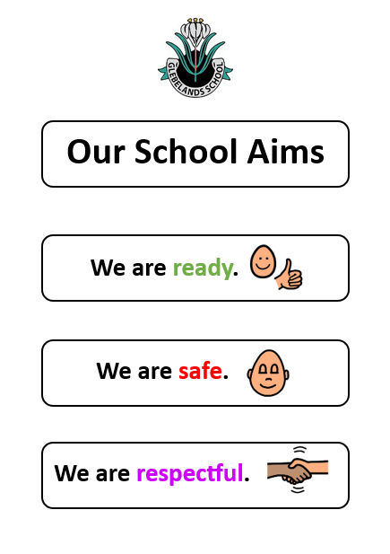
We are Ready:
- We are ready to learn.
- We are ready to listen to and follow instructions the first time.
- We are ready to always support each other.

We are safe:
- We use our strategies, adult support and spaces to help us keep ourselves
and others safe.
- We have clear expectations of behaviour, manners and self-regulation to
help us be ready and keep ourselves and others safe.
- We are supported equitably to help us learn and grow our skills for
independence.

We are respectful:
- We treat each other with fairness, dignity and respect.
- We treat each other the way we expect to be treated.
- We receive support to help us restore and repair relationships.

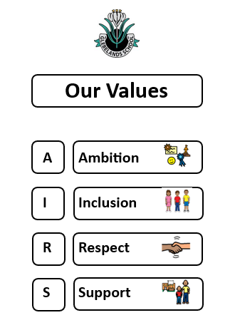
Context of the School

Glebelands Primary School is an inner-city school with a wide-ranging and diverse catchment area. There are currently 366 primary and 64 nursery pupils at the school, the majority of whom live within SIMD deciles 1 to 4. Almost a quarter of our school population speak English as an additional language and we have children who can speak 31 different world languages.

We are situated in a built-up area, mainly residential, just to the north of the city centre and serve the Stobswell and Baxter Park areas of Dundee within the Maryfield Ward. Our school building is a large Edwardian building on three levels with teaching areas on the first and second floors, as well as teaching areas on and other teacher and lower and upper mezzanines. In addition to this we have a family room and supported teaching area on the ground floor.
The staff team is led by the Head Teacher, a Depute Head Teacher and one Principal Teacher. There are currently 14 primary classes each with a full-time equivalent teacher, and additional teaching staff supporting equitable teaching interventions to raise attainment. This session we also have a School and Family Development Worker, one Administrative Officer and seven support staff, and one lunchtime supervisor. The nursery has 16 staff including 2 Senior Practitioners and a 4 day teacher. The school is part of the Morgan Academy Cluster and positive relationships exist among all cluster schools supporting cluster improvement priorities.
Staff know the pupils well and have high expectations of learning and behaviour. There is a positive and supportive ethos across the school which is commented on by visitors, with ‘dignity’ highlighted as a strength by recent Education Scotland HMIe Inspectors.
Our school vision is:

An inspirational community striving for excellence in learning through a culture of innovation, challenge, inclusion and the celebration of success

and our strapline is:
Be the Best Possible You

This is underpinned by our values which are:

Ambition Inclusion Respect Support

We aim to provide a happy, safe, and welcoming environment for all members of our school community and seek to ensure that everyone is treated fairly and equally with the opportunity and support to develop and achieve to their full potential. We value respect, honesty and commitment and strive to deliver high quality learning and teaching experiences so that pupils are equipped with skills for learning, life, and work.

Attainment Data 2022-2023

 | Reading | Writing | Talking and Listening | Numeracy
Primary 1  (CFE Early Level) | 81% | 80% | 79% | 88%
Primary 4  (CFE 1st Level) | 85% | 81% | 81% | 87%
Primary 7  (CFE 2nd Level) | 91% | 82% | 89% | 84%

Attainment Data 2023-2024

 | Reading | Writing | Talking and Listening | Numeracy
Primary 1  (CFE Early Level) | 79% | 71% | 88% | 90%
Primary 4  (CFE 1st Level) | 75% | 73% | 91% | 78%
Primary 7  (CFE 2nd Level) | 84% | 85% | 97% | 85%

Attainment Data 2024-2025

 | Reading | Writing | Talking and Listening | Numeracy
Primary 1  (CFE Early Level) | 86% | 92% | 89% | 94%
Primary 4  (CFE 1st Level) | 86% | 82% | 88% | 78%
Primary 7  (CFE 2nd Level) | 82% | 82% | 80% | 76%

*Please be mindful when analysing data that each year our cohort of children are different learners and our attainment over time for cohorts of children are used to support measuring impact for individual progress. Further analysis information included below.
Review of Improvement Progress for Session 2025-2026


Every Dundee Learner Matters
Our main focus for improving learning aligns with the wider Dundee Strategy of Every Dundee Learner Matters (EDLM) and is based on collaboration amongst staff to find alternative ways of working to increase pupils’ chances of success. The rationale for EDLM involves making improvements in one or more of the “Three Ps” – Presence, Participation and Progress. This year the focus has been on the following improvement priorities:
School Improvement Priority 1: PRESENCE

Improving learner attendance and lateness

Rationale for Improvement: Authorised and unauthorised absence data and patterns of absences increasing.

Progress and Impact

This year we have worked collegiately across schools to review and analyse data patterns and trends, as well as moderate our practice to identify the most supportive and effective models for improvement to help decrease absences across the school.

Our Senior Leadership Team and School and Family Development Worker works alongside our office and school staff to identify areas of concern for targeted support interventions that have addressed barriers to attendance.

Using evidence based-approaches and data analysis, supportive measures have been established to identify barriers to attendance. This has supported staff to engage families and children to work together to plan support interventions. We now have made improvements to our Attendance processes and routines to support early intervention and prevention of school absence. Targeted support has been prioritised and as a result, effective partnership working between home and school and other agencies of support, has led to improvements in attendance for all targeted families. Furthermore, this has improved relationships with families to identify ways to work together and improve children’s Presence in school, leading to improvements in their Participation and Progress in learning.

Pupil Equity Funding (PEF)

This session we used PEF to pay for our School and Family Development Worker, an additional Support Staff Member and release 2 additional teachers to support Targeted Interventions for Equity and improve the PRESENCE of identified children across the school. This also allowed us to set up 2 new teaching and support areas within the school, offering learning spaces developed as a result of ‘children’s voice’ and ‘family voice’. This highlighted key areas requiring support for children to improve attendance in school including the following:

Support children to get children to school, identify and implement parenting strategies, support interventions including ‘meet and greet’, supported breaks and lunchtime provision, parent drop in support, targeted support strategies and spaces across all classrooms, support classroom provision for targeted teaching and learning approaches, pupil regulation spaces to learn and apply self-regulation.

ALL targeted children have improved their attendance in school.

Data Analysis

As part of the Strategic Equity Fund, Dundee has set Stretch Aims for Attendance for 2025/26. We are making significant improvements to attendance and as of 4th June 2025,as can be seen below. We have continued to improve and have exceeded our Dundee Attendance Stretch Aim 24/25 of 91.7%, achieving 94.8% attendance as of 4th June 2025.

See below for statistics:

School Level Attendance Data

 | 2020/21 | 2021/22 | 2022/23 | 2023/24 | 2024/25  (06/05/25)
Glebelands | 93.7% | 89.3% | 89.7% | 90.8% | 94.3%

Next Steps:
Introduction of a new tracking system will support developing staff capacity to interrogate attendance and lateness data for improvement. This will increase teacher confidence and responsibility to ensure early intervention to support improving the Presence of our children in school.
Continue with current processes and procedures in place for early identification and support.
A focus on evaluating and improving our high-quality learning and teaching experiences and opportunities for children are robustly planned and evaluated, to ensure that children experience a curriculum that is enriched, coherent, relevant and progressive.
Improvements to Pupil Voice to support improving lateness and attendance MUST be a focus for improvement.

School Improvement Priority 2: PARTICIPATION

Personalised Support Planning
Continuity & Consistency of Inclusive Learning Environments across the school.

Rationale for Improvement: To ensure ALL CHILDREN are benefitting from high-quality universal support and high-quality learning environments.

This session, we have used our Pupil Equity Funding to increase our staffing in school, and support improving our learning environments and curricular offer for ALL CHILDREN across the school.
We have continued to work closely with our colleagues at Longhaugh Support Group, the Department of Educational psychology and the Accessibility and Inclusion Service to embed and improve our universal and targeted supports to ensure that we meet the needs of ALL CHILDREN at Glebelands Primary School. We have engaged in professional learning and pedagogy to improve how we assess and report on children’s progress, not only academically but also how we assess, track and monitor progression in the development of social skills.
We have used the Dundee Standard for Inclusion to audit and improve our Learning Environments across all stages of the school and embedded our Inclusive Learning Expectations in consistent learning environments in all classrooms and shared spaces. We have cleared out, enhanced and decorated almost all of the classrooms this session and replaced the flooring to the upper floor.
As a result:
All children are nurtured and supported in inclusive learning classrooms and spaces. Our school is enhanced with visuals to support communication. This provides our children with clear structure and routine, improves understanding and avoids frustration and anxiety. Visuals play a crucial role in supporting children's learning in our school by enhancing comprehension, improving memory retention, and promoting engagement. They offer concrete representations of abstract concepts, making learning more accessible and enjoyable for various learning styles.
All children have access to at least 1 Calm Space in their classroom, where they can go to help them if needed. All calm spaces have soft furnishings, sensory toys and objects and Feelings visuals to help them have a break or self-regulate when needed. Additional break out spaces are available for children to access when and if needed.
All children experience a visualised timetable of their day in All classrooms. Where there is an identified need, some children are supported with individual visual timetables to support them to increase their independence for learning.
All children have access to Visualised ‘Fix It Folders’ in their classroom and other learning spaces. This is used to support children when something goes wrong. This helps children to work through a visualised representation when something goes wrong, to engage in a restorative discussion that supports their understanding of not only their own feelings and understanding of a situation, but also the feelings and understanding of others.
Some families have been supported using visuals at home to address barriers for children at home. These include mini fix-it folders, visualised routines, such as toileting, bedtime and morning routines, changes and holidays. Some children and families are also supported using visualised social stories that provide clear, simple explanations and visual aids to help children grasp social cues, expectations and appropriate responses. Visualised social stories help children by making social situations easier to understand and navigate, which can reduce anxiety and improve behaviour.
All teachers feel more confident to use a range of assessments to assess and track children’s progress in learning and beyond. Teachers engage confidently in Team Around the Children Meetings to work collaboratively with families and other agencies to best meet the needs of children.
Children requiring additional support to address barriers to learning are supported with ABLE Plans (Addressing Barriers to Learning). Some children are supported with Targeted and Individualised Plans, such as Care and Risk Management Plans and are then supported through interventions for Equity.
70 children across the school have been supported with 1 or more Intervention for Equity this session.
Targeted Children and groups of children have been supported in small ground interventions to help address barriers to learning and increase their individual participation in school. As a result, attendance for all targeted children has increased.
100% of targeted children are engaging in their planned learning in school and have demonstrated progress in all of their targets – academic, social, emotional and behavioural. As a result, children experience warm, nurturing relationships with adults in school to ensure that they feel safe, listened to, understood, supported and loved.

Next Steps:

Continue to work as part of a multiagency approach with families to best support ALL children in our school. Including regular audits of our Inclusive Practice to ensure consistency of approach that best meets children’s needs.

Continue to embed new and improved assessment tools to set targets and best track learner progress over time.

Deliver training to all staff to implement a new tracking system across the school in line with Dundee City 3 year Implementation Plan to report on children’s progress.

.

School Improvement Priority 2: PROGRESS

High Quality learning, teaching & assessment
Self-evaluation & moderation culture for improvement – learning, teaching and assessment

Rationale for Improvement: To ensure that learner experiences are appropriately challenging and enjoyable, matched to their needs and interests and that there is a shared understanding evident across the school, underpinning the teaching, learning and assessment of ALL learners. Staff to make effective use of assessments and their shared understanding of standards to make confident professional judgements about children’s progress.

This session we audited and reviewed our current data analysis and pupil tracking systems to identify areas for improvement. We have engaged in collegiate development sessions to increase staff confidence and competence to analyse and use data to inform daily teaching and learning approaches for improvement.
Staff have engaged in research, professional reading and professional learning to enhance learning in the Outdoors for All Children across the school. Outdoor Education has been planned to support children to develop their transferable skills for learning, life and work.
Staff have participated in professional learning to learn about and implement the use of Quality Improvement tools to improve learning, teaching and assessment, particularly in writing. 3 teachers participated in the National Improving Writing Programme to improve writing in P4 and all other staff participated in Quality Improvement Training alongside this to improve skillset of all staff across all levels, from P1 – P7, to improve Writing.
We continued to embed our Learn to Read programme across P1 – 3. Our Reading Improvement Leaders continued to work with Ruth Miskin Staff and engage in development days to improve our pace and challenge for children.
As a result:
ALL CHILDREN have experienced weekly opportunities to engage in Outdoor Learning Experiences on school grounds and in local spaces, This has enriched their learning and provided engaging, creative, challenging and adventurous opportunities to help all children learn and grow as confident and responsible citizens who value and appreciate their local environment. They have been supported development of their transferable skills for learning, life and work, such as self-management and self-regulation, communication, collaboration, critical thinking, adaptability and resilience.
All children experience opportunities to use Digital Technology to increase their independence in learning through supportive learning software and apps.
Children with English as an Additional Language (EAL) are supported by visiting Teacher Specialists to improve their skills for independence and language acquisition levels., therefore improving attainment in Literacy and Numeracy.
Primary 1
- 92% of Primary 1 children achieved Early Level Writing.
- 86% of Primary 1 children achieved Early Level Reading.
- 89& of Primary 1 children achieved Early Level Listening & Talking.
- 86% of P1 children achieved overall Literacy. Stretch Aim for 25/26 is 80%. (Passing early level in all 3 areas - Reading, Writing & Listening & Talking.)
- 94% of P1 children achieved Early Level Numeracy.
Primary 2
- 88%​ of Primary 2 children are on track to achieve First Level Listening & Talking.
- 88%​ of Primary 2 children are on track to achieve First Level Reading
- 83%​ of Primary 2 children are on track to achieve First Level Writing
- 83% of Primary 2 children are on track to achieve overall Literacy. (Passing early level in all 3 areas - Reading, Writing & Listening & Talking.)
- 80% of Primary 2 children are on track to achieve First Level Numeracy.
Primary 3​
- 75%​ of Primary 3 children are on track to achieve First Level Listening & Talking.
- 59%​ of Primary 3 children are on track to achieve First Level Reading.
- 60% of Primary 3 children are on track to achieve First Level Writing.​
- 35% of Primary 3 children are on track to achieve Overall Literacy. (Passing early level in all 3 areas - Reading, Writing & Listening & Talking.)
- 71% of Primary 3 children are on track to achieve First Level Numeracy.
Primary 4
- 86%​ of Primary 4 children achieved First Level Listening & Talking.
- 82%​ of Primary 4 children achieved First Level Reading.
- 88% of Primary 4 children achieved First Level First Level Writing.​
- 75% of Primary 4 children achieved Overall Literacy. (Passing early level in all 3 areas - Reading, Writing & Listening & Talking.)
- 78% of Primary 4 children achieved First Level Numeracy.
Primary 5
- 85%​ of Primary 5 children are on track to achieve Second Level Listening & Talking.
- 75%​ of Primary 5 children are on track to achieve Second Level Reading.
- 68%​ of Primary 5 children are on track to achieve Second Level Writing.
- 65% of Primary 5 children are on track to achieve Overall Literacy. (Passing early level in all 3 areas - Reading, Writing & Listening & Talking.)
- 83% of Primary 5 children are on track to achieve Second Level Numeracy.
(Continued below)

Primary 6
- 86%​ of Primary 6 children are on track to achieve Second Level Listening & Talking.
- 80%​ of Primary 6 children are on track to achieve Second Level Reading.
- 82%​ of Primary 6 children are on track to achieve Second Level Writing.
- 79% of Primary 6 children are on track to achieve Overall Literacy. (Passing early level in all 3 areas - Reading, Writing & Listening & Talking.)
- 91% of Primary 6 children are on track to achieve Second Level Numeracy.
Primary 7
- 85%​ of Primary 7 children achieved Second Level Listening & Talking.
- 75%​ of Primary 7 children achieved Second Level Reading.
- 68%​ of Primary 7 children achieved Second Level Writing.
- 76% of Primary 7 children achieved Overall Second Level Literacy.
- EN – 33/40 = 83% of Primary 5 children achieved Second Level Numeracy.
Next Steps:

Continue to embed Quality Improvement Tools and learning to target improvement interventions for raising attainment in Literacy and Numeracy.

Engage in professional learning opportunities to develop the use of a new whole school tracking and monitoring system that will ensure that children’s attainment and achievement over time demonstrates improving presence, participation, and progress.
.
Moderate, review and engage in professional learning to ensure that our curricular planning and evaluation practices ensure breadth, depth and challenge for all children, incorporating meta-skills for life and work and providing learning experiences with relevance, coherence and challenge.

Moderation of standards within learning and teaching continues to be a city-wide focus and in-house support through our Quality Assurance Moderation Support Officer (QAMSO) will continue.

Pupil Equity Funding

Our Pupil Equity funding (April 24 to March 25) was used to support developments across the school last session, including the following:

- Additional staffing – teaching staff, support staff and School and Family Development Worker.
- Learning & Teaching resources to support raising attainment.
- Replacing broken and old resources.
- Health & Wellbeing resources to support targeted interventions.
- Reducing the Cost of the School Day – clothing and equipment, learning trips and transport, healthy snacks and water.
- Developing Inclusive Learning Classrooms to meet all children’s needs.
- Developing learning spaces across the school, both inside and outside.

Session 2025/2026 projected spend (April 25 – March 26) will be used to continue our supported developments above in relation to our new School Improvement Plan. More information will be available on our projected spend to follow.

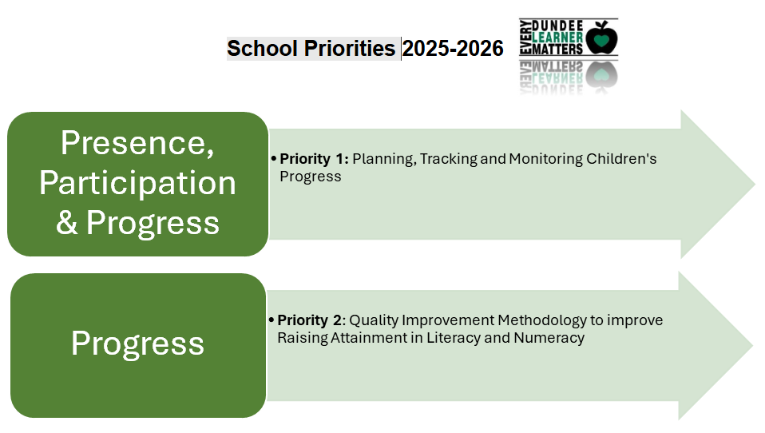

Please visit www.careinspectorate.com or https://education.gov.scot/what-we-do/inspection-and-review/reports for Care Inspectorate or HMIE Inspection Reports.

https://parentzone.org.uk/

Further Information can be found at:

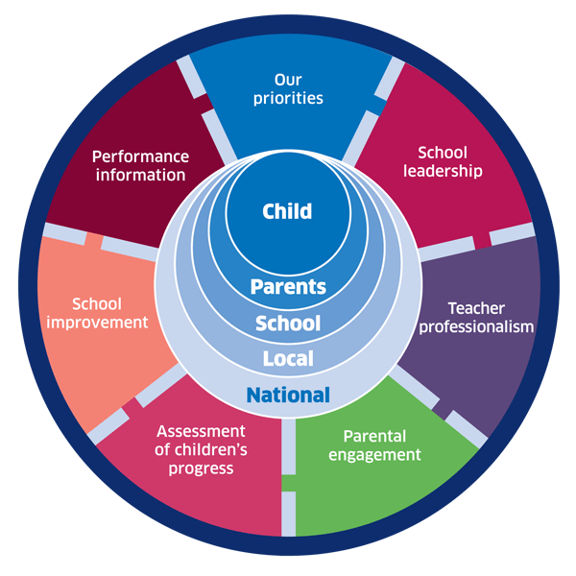 | 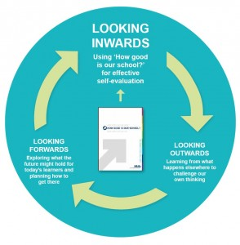 |  | 
National Improvement Framework
http://www.gov.scot/Publications/2016/01/8314
HGIOS 4 Self-evaluation https://education.gov.scot/improvement/Documents/Frameworks_SelfEvaluation/FRWK2_NIHeditHGIOS/FRWK2_HGIOS4.pdf
Tayside Plan C&FS
External Link ' Tayside_Plan 1a.pdf'
Dundee Education Plan
https://www.dundeecity.gov.uk/sites/default/files/publications/annual_education_plan_2017-18.pdf

